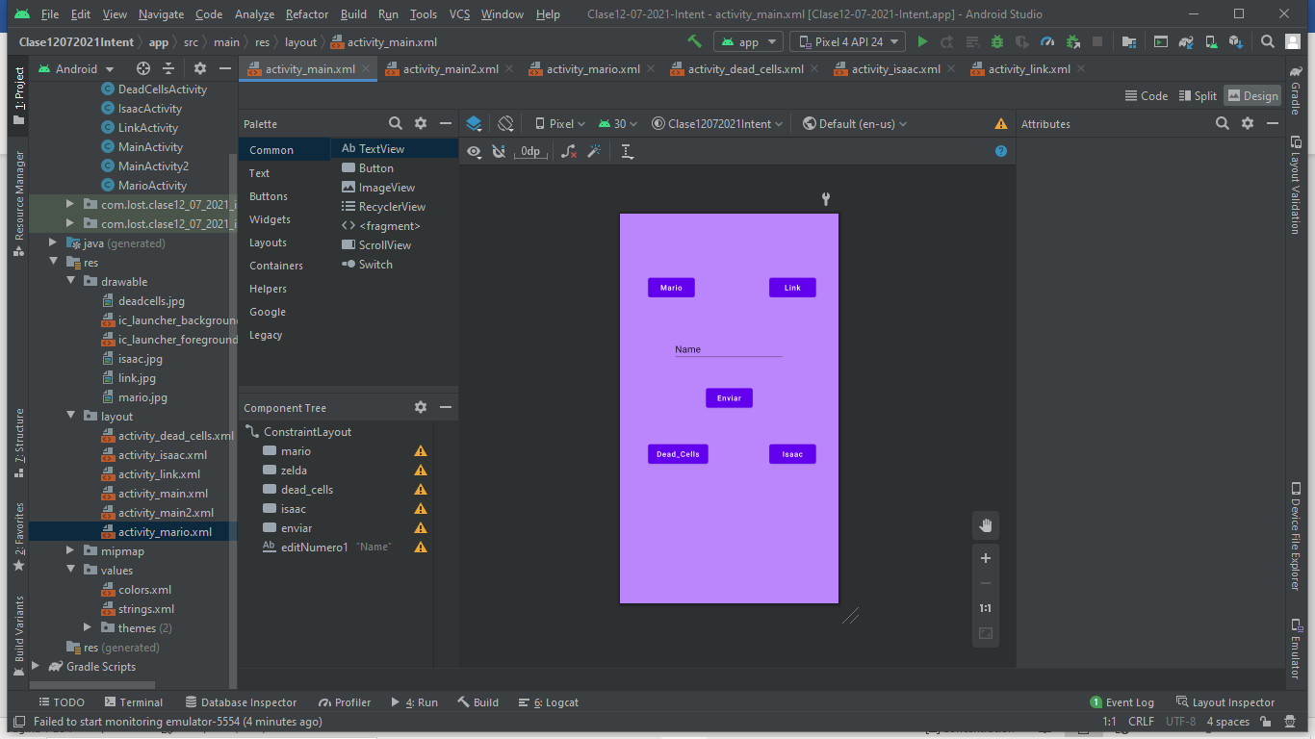
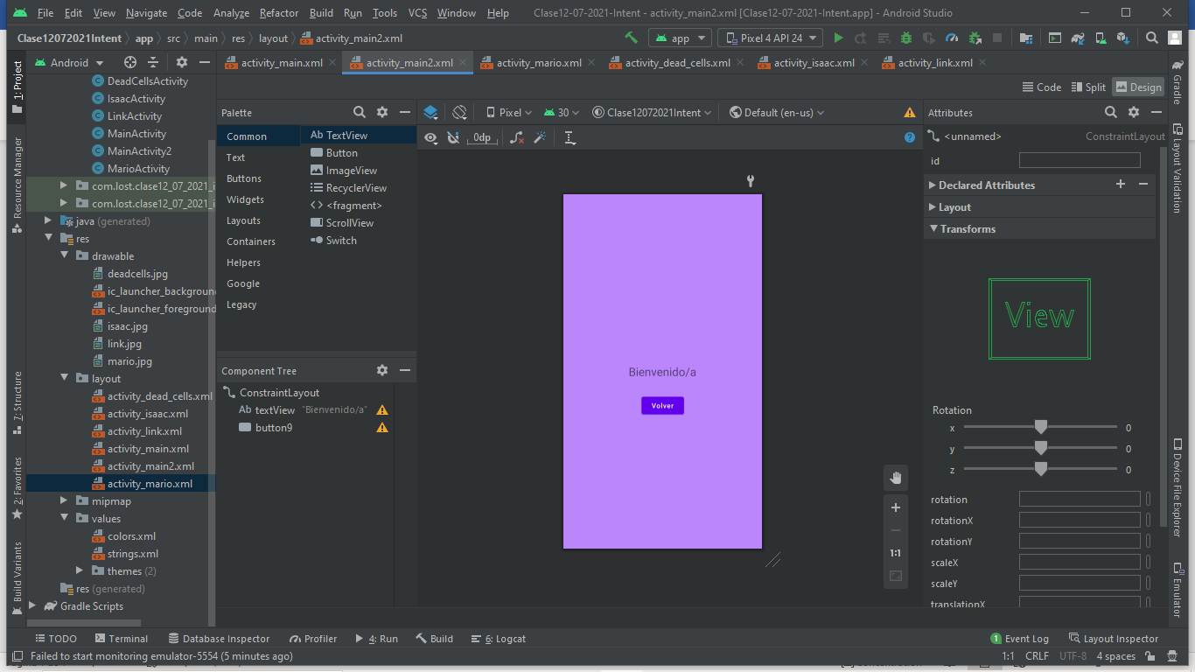

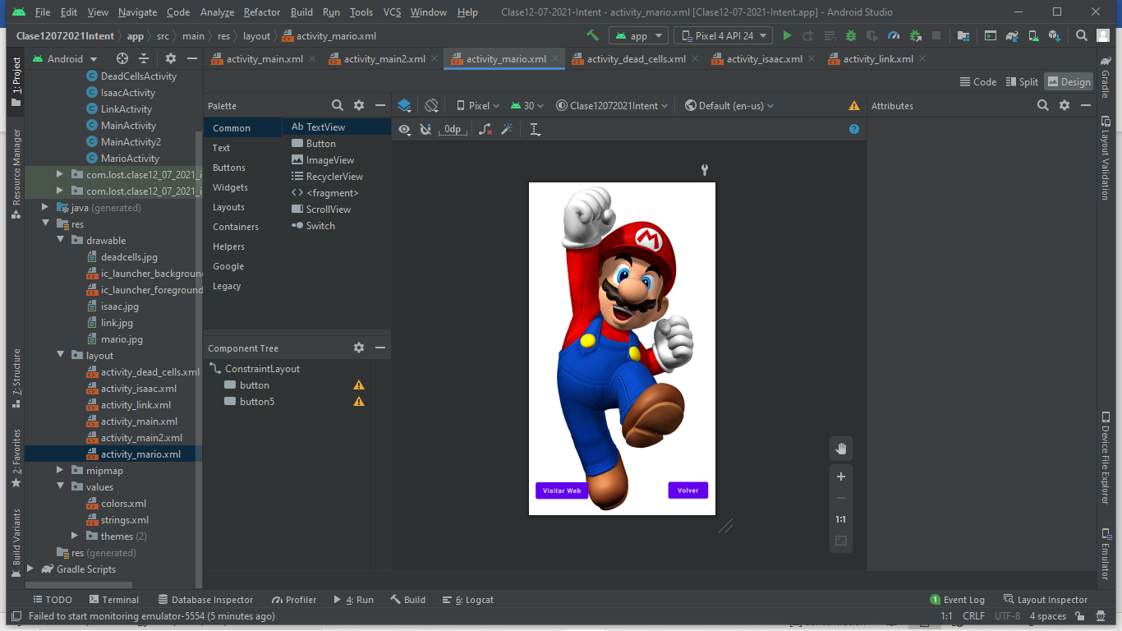
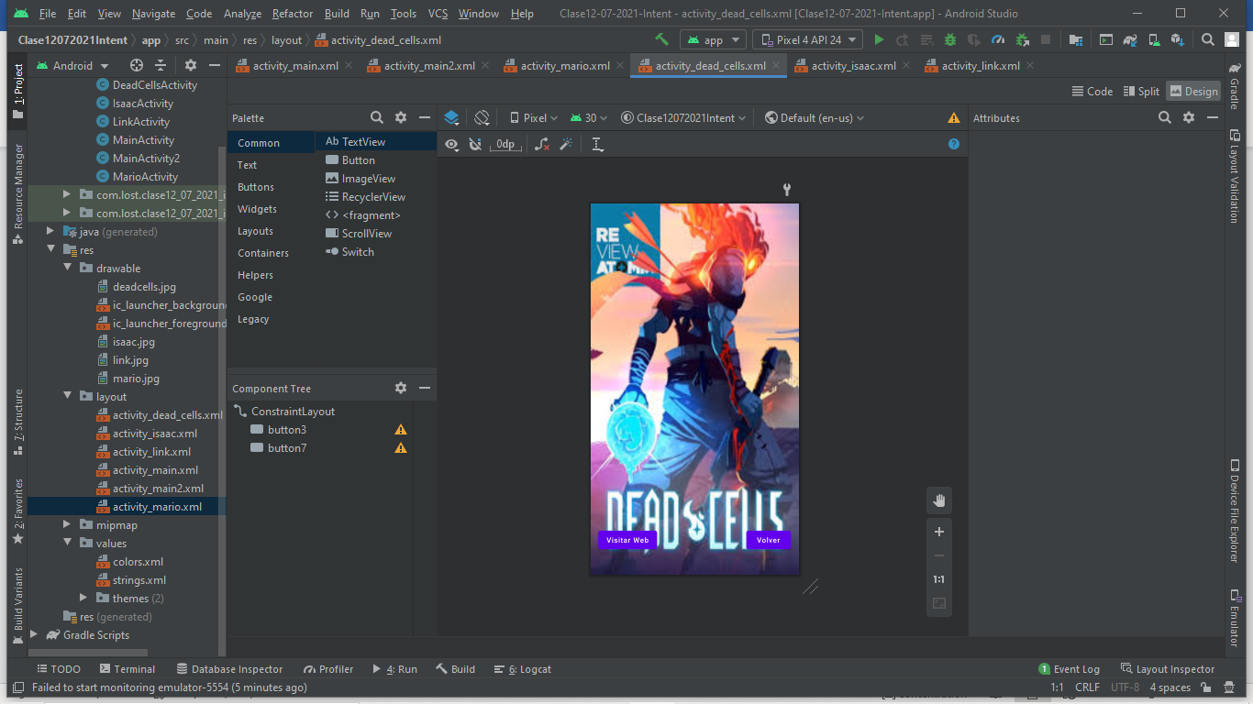

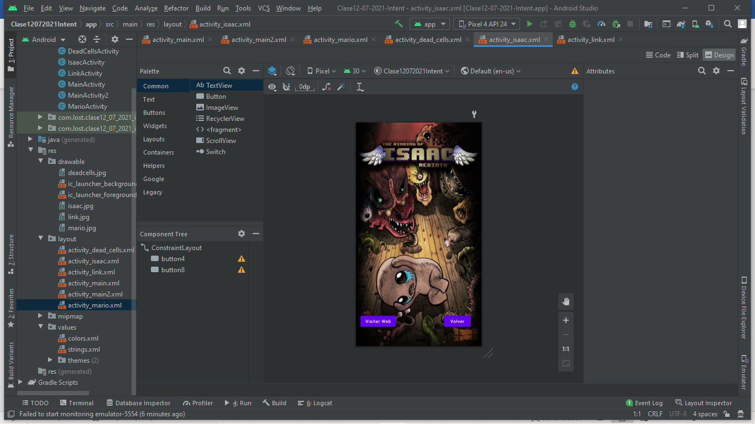
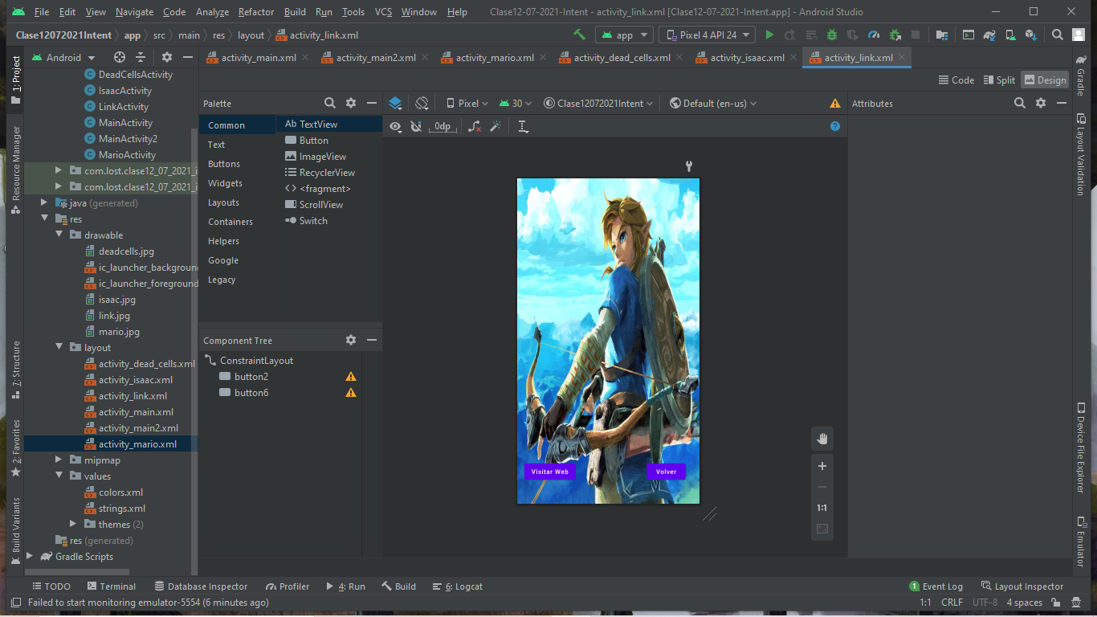

//CODIGO
package com.lost.clase12_07_2021_intent;
import androidx.appcompat.app.AppCompatActivity;
import android.content.Intent;
import android.os.Bundle;
import android.view.View;
import android.widget.EditText;
public class MainActivity extends AppCompatActivity {
private EditText texto;
@Override
protected void onCreate(Bundle savedInstanceState) {
super.onCreate(savedInstanceState);
setContentView(R.layout.activity_main);
texto = findViewById(R.id.editNumero1);
}
public void enviarNombre(View view){
Intent intent = new Intent(this, MainActivity2.class);
intent.putExtra("nombre", texto.getText().toString());
startActivity(intent);
}
public void mario(View view){
Intent intent = new Intent(this, MarioActivity.class);
startActivity(intent);
}
public void link(View view){
Intent intent = new Intent(this, LinkActivity.class);
startActivity(intent);
}
public void deadCells(View view){
Intent intent = new Intent(this, DeadCellsActivity.class);
startActivity(intent);
}
public void isaac(View view){
Intent intent = new Intent(this, IsaacActivity.class);
startActivity(intent);
}
}

//CODIGO 2
package com.lost.clase12_07_2021_intent;
import androidx.appcompat.app.AppCompatActivity;
import android.content.Intent;
import android.os.Bundle;
import android.view.View;
import android.widget.TextView;
public class MainActivity2 extends AppCompatActivity {
private TextView texto;
@Override
protected void onCreate(Bundle savedInstanceState) {
super.onCreate(savedInstanceState);
setContentView(R.layout.activity_main2);
texto = findViewById(R.id.textView);
String nombre = getIntent().getStringExtra("nombre");
texto.setText("Bienvenido/a: " + nombre);
}
public void volver(View view){
Intent intent = new Intent(this, MainActivity.class);
startActivity(intent);
}
}

//CODIGO 3
package com.lost.clase12_07_2021_intent;
import androidx.appcompat.app.AppCompatActivity;
import android.content.Intent;
import android.net.Uri;
import android.os.Bundle;
import android.view.View;
public class DeadCellsActivity extends AppCompatActivity {
@Override
protected void onCreate(Bundle savedInstanceState) {
super.onCreate(savedInstanceState);
setContentView(R.layout.activity_dead_cells);
}
public void volver(View view){
Intent intent = new Intent(this, MainActivity.class);
startActivity(intent);
}
public void visitarWeb(View view){
Uri uri = Uri.parse("https://dead-cells.com/");
Intent intent = new Intent(Intent.ACTION_VIEW, uri);
startActivity(intent);
}
}

//CODIGO 4
package com.lost.clase12_07_2021_intent;
import androidx.appcompat.app.AppCompatActivity;
import android.content.Intent;
import android.net.Uri;
import android.os.Bundle;
import android.view.View;
public class IsaacActivity extends AppCompatActivity {
@Override
protected void onCreate(Bundle savedInstanceState) {
super.onCreate(savedInstanceState);
setContentView(R.layout.activity_isaac);
}
public void volver(View view){
Intent intent = new Intent(this, MainActivity.class);
startActivity(intent);
}
public void visitarWeb(View view){
Uri uri = Uri.parse("https://bindingofisaac.fandom.com/es/wiki/The_Binding_of_Isaac");
Intent intent = new Intent(Intent.ACTION_VIEW, uri);
startActivity(intent);
}
}

//CODIGO 5
package com.lost.clase12_07_2021_intent;
import androidx.appcompat.app.AppCompatActivity;
import android.content.Intent;
import android.net.Uri;
import android.os.Bundle;
import android.view.View;
public class LinkActivity extends AppCompatActivity {
@Override
protected void onCreate(Bundle savedInstanceState) {
super.onCreate(savedInstanceState);
setContentView(R.layout.activity_link);
}
public void volver(View view){
Intent intent = new Intent(this, MainActivity.class);
startActivity(intent);
}
public void visitarWeb(View view){
Uri uri = Uri.parse("https://www.zelda.com/");
Intent intent = new Intent(Intent.ACTION_VIEW, uri);
startActivity(intent);
}
}

//CODIGO 6
package com.lost.clase12_07_2021_intent;
import androidx.appcompat.app.AppCompatActivity;
import android.content.Intent;
import android.net.Uri;
import android.os.Bundle;
import android.view.View;
public class MarioActivity extends AppCompatActivity {
@Override
protected void onCreate(Bundle savedInstanceState) {
super.onCreate(savedInstanceState);
setContentView(R.layout.activity_mario);
}
public void Volver(View view){
Intent intent = new Intent(this, MainActivity.class);
startActivity(intent);
}
public void visitarLink(View view){
Uri uri = Uri.parse("https://www.nintendo.com/");
Intent intent = new Intent(Intent.ACTION_VIEW, uri);
startActivity(intent);
}
}

//STRINGS
